**Chapter 1**

**Introduction**

* 1. **Introduction**

Determining whether the listed price of a used car is a challenging task, due to the many factors that drive a used vehicle’s price on the market. The focus of this project is developing machine learning models that can accurately predict the price of a used car based on its features, in order to make informed purchases. We implement and evaluate various learning methods on a dataset consisting of the sale prices of different makes and models. We will compare the performance of various machine learning algorithms like Linear Regression, Ridge Regression, Lasso Regression, Elastic Net choose the best out of it. Depending on various parameters we will determine the price of the car. Regression Algorithms are used because they provide us with continuous value as an output and not a categorized value because of which it will be possible to predict the actual price a car rather than the price range of a car. User Interface has also been developed which acquires input from any user and displays the Price of a car according to user’s inputs.

The Used Vehicle Price Prediction System aims to revolutionize the way prices are determined for pre-owned vehicles. Traditional methods of price evaluation often lack accuracy and transparency, leading to inconsistent and subjective results. The proposed system utilizes data-driven approaches and machine learning algorithms to provide reliable and objective price predictions. This report introduces the system, highlighting its features, functionality, and potential benefits for buyers and sellers in the used vehicle market. By offering an improved and transparent pricing mechanism, the system aims to enhance trust, efficiency, and informed decision-making in the industry.

**1.2 Motivation**

The motivation behind developing a Used Vehicle Price Prediction System stems from the challenges and limitations faced by traditional methods of pricing pre-owned vehicles. The existing system, often reliant on individual expertise or subjective assessments, can result in inconsistent and biased price evaluations. This lack of accuracy and transparency creates obstacles for both buyers and sellers in the used vehicle market.

Overall, the motivation behind the development of the Used Vehicle Price Prediction System is to overcome the limitations of traditional methods and introduce a reliable, objective, and transparent pricing mechanism. By empowering buyers and sellers with accurate price predictions, the system aims to foster trust, efficiency, and fairness in the used vehicle market.

**1.3 Purpose**

The purpose of the Used Vehicle Price Prediction System is to revolutionize the process of determining prices for pre-owned vehicles. Traditional methods often rely on subjective assessments and individual expertise, leading to inconsistencies and potential biases. The system addresses these limitations by leveraging historical sales data and advanced machine learning algorithms to provide accurate and transparent price estimates. Its purpose is to empower buyers and sellers with reliable information, enabling informed decision-making and fair negotiations. By promoting transparency, reducing information asymmetry, and streamlining the pricing process, the system enhances market efficiency and fosters trust among participants. With its data-driven approach and technological advancements, the system brings objectivity, fairness, and efficiency to the used vehicle market, benefiting both buyers and sellers alike.

**1.4 Objective**

The objective of application is to predict the price of used vehicles using machine learning models. There are some objectives about system:

* To study about brands and types of the vehicle
* To study model of the vehicle, year of manufacturing of vehicle, type of fuel, Ex-Showroom price
* To study about machine learning concepts and processing data to predict things

**Chapter 2**

**Literature Survey**

**2.1 Existing System**

The existing system of used vehicle price determination can vary depending on the region and market. In many cases, the current approach involves manual valuation by individuals based on limited information.

Individuals with experience in the automotive industry, such as car dealers, use their knowledge and expertise to estimate the value of a used vehicle. They consider factors like the vehicle's make, model, age, mileage, condition, and market demand

* + 1. **Referred Journal/Conference Papers**

**1 . Gongqi, S., Yansong, W., & Qiang, Z. (2011, January). New Model for Residual Value Prediction of the Used vehicle Based on BP Neural Network and Nonlinear Curve Fit. In Measuring Technology and Mechatronics Automation (ICMTMA), 2011 Third International Conference on (Vol. 2, pp. 682-685). IEEE.**

**2. K. Samruddhi and R. Ashok Kumar, "Used vehicle Price Prediction using K-Nearest Neighbor Based Model", International Journal of Innovative Research in Applied Sciences and Engineering, vol. 4, no. 3, pp. 686-689, 2020.**

**3. USED CAR PRICE PREDICTION Praful Rane1, Deep Pandya2, Dhawal Kotak3 1-3 Information Technology Engineering, Padmabhushan Vasantdada Patil Pratisthan College of Engineering, Maharashtra India.**

**2.2 Problem Statement**

If anyone wants to sell their vehicle either they have to take their vehicle to a respective company workshop or have to make an appointment for the company to get an estimate of the price. This process involves a lot of time and resources. Our Objective is to make a model for customer that will make an estimate of the Price of the customer’s vehicle directly.

**2.3 Proposed System**

The proposed system for used vehicle price prediction aims to enhance the accuracy, efficiency, and transparency of determining the value of a used vehicle.

The proposed system aims to predict the price of used vehicle by machine learning and user-friendly interfaces to provide more accurate, transparent, and reliable price predictions.

**2.4 Feasibility Study**

The feasibility study for the Used Vehicle Price Prediction System indicates its strong potential for success. From a technical perspective, the system leverages readily available technologies such as data analytics and machine learning algorithms, ensuring its technical feasibility. In terms of economic viability, the system offers cost savings for buyers and revenue generation opportunities through monetization strategies.

It also complies with legal and regulatory requirements, prioritizing data protection and privacy. Operationally, the system is designed with a user-friendly interface and can be integrated with existing platforms, enhancing its usability. A realistic schedule, adequate resources, and diligent project management ensure timely delivery. Market research confirms the demand for such a system and highlights opportunities for collaboration with industry stakeholders. Taking all these factors into account, the feasibility study concludes that the Used Vehicle Price Prediction System is feasible and holds promise for successful implementation in the market.

**Chapter 3**

**Project Scope and Requirement Analysis**

**3.1 Project Scope**

Determining the price of used vehicle is a challenging task, due to the many factors that drive a used vehicle’s price in the market. The aim of this project is developing machine learning model that can predict appropriate price for used vehicle based on its features and past data.

**3.2 Requirement Gathering and Analysis**

 The system takes following parameters into consideration as Car Company, car model, purchase year, fuel type and kilometers driven based on these parameters.

1. Input Data: Gather previous vehicles data including parameters like car model, purchase year, fuel type, kilometers driven, etc.

2. User Input: Allow users to input company, car model, purchase year, fuel type and kilometers driven.

3. Data Pre-processing: Clean and pre-process the input data to ensure consistency and remove any irrelevant or incomplete information. This step may involve data normalization, feature scaling, and handling missing values.

5. Machine Learning Models: Develop machine learning models that can analyze the input data and make price estimation based on the provided input features. Possible model choices include linear regression.

6. Training Data: Prepare a labelled dataset that includes historical car data. This data will be used to train and validate the machine learning models.

7. Model Training: Train the machine learning models using the labelled dataset, adjusting hyper parameters and optimizing the models for accurate price estimation.

**Chapter 4**

**Project Design and Modeling Details**

**4.1 Software Requirement Specification (SRS)**

**1. Introduction:**

The purpose of the Used Vehicle Price Prediction System is to provide accurate and transparent price estimates for pre-owned vehicles, facilitating informed decision-making, promoting fairness, and enhancing market efficiency.

**2. User Requirements**

* Identify the target users of the system, such as buyers, sellers, and automotive professionals.
* Understand their needs and expectations regarding price estimation, data accuracy, usability, and system features.
* Gather feedback on the existing challenges and limitations in the current process of determining used vehicle prices.

**2.1 Functional Requirements**

* Capture the essential system functionalities, including vehicle information input, data validation, feature extraction, price prediction, etc.
* Define the scope and specifications of each module, ensuring they align with user requirements.
* Determine any additional features that may enhance the user experience and provide value-added services.

**2.2 Non-Functional Requirements**

* Identify the non-functional requirements such as usability, performance, reliability, scalability, security, privacy, accuracy, adaptability, etc.
* Ensure the system is scalable to handle increased user load and accommodate future growth.
* Define security measures, such as data encryption, access controls, and to protect user information.

**2.3 Constraints**

* Identify any limitations or constraints that may impact the system design and development, such as budgetary constraints, time constraints, or technological limitations.

**4.2 System Modules**

**1. Vehicle Information Module:**

* This module captures and stores the details of the vehicle being evaluated, such as make, model, year, mileage, condition, VIN (Vehicle Identification Number), and optional features.
* It allows users to input specific vehicle attributes that contribute to the price prediction process.

**2. Historical Data Module:**

* This module collects and maintains historical sales data, market trends, and price fluctuations of similar vehicles.
* It provides valuable insights into the overall market conditions and helps adjust price predictions based on current trends.

**3. Data Pre-processing Module:**

* This module pre-processes the input data to handle missing values, outliers, categorical variables, and data normalization.
* It ensures that the data is in a suitable format for the price prediction algorithms and enhances the quality of predictions.

**4. Model Training and Validation Module:**

* This module trains the price prediction model using the available historical data, splitting it into training and validation sets.
* It performs cross-validation techniques, such as k-fold cross-validation, to assess the model's performance and avoid overfitting.

**5. Machine Learning Module:**

* Trains and fine-tunes machine learning models based on historical vehicle data

**4.3 System Modelling and Design**

**1. Use case Diagram**

A use case diagram is a visual representation of the interactions between actors (users or external systems) and a system. It illustrates the various use cases or functionalities of a system and how different actors are involved in those use cases

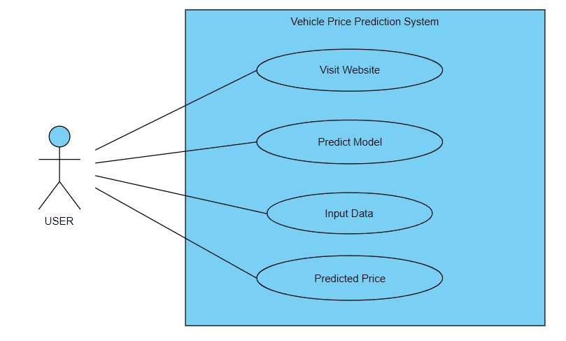

**2. Sequence Diagram**

A sequence diagram is a type of interaction diagram that illustrates the interactions and message exchanges between different objects or components in a system over a specific time period. It shows the order in which messages are sent and received, highlighting the flow of communication and the collaboration between system elements. Sequence diagrams are useful for visualizing the dynamic behavior of a system and understanding the sequence of actions performed during a specific scenario or use case.

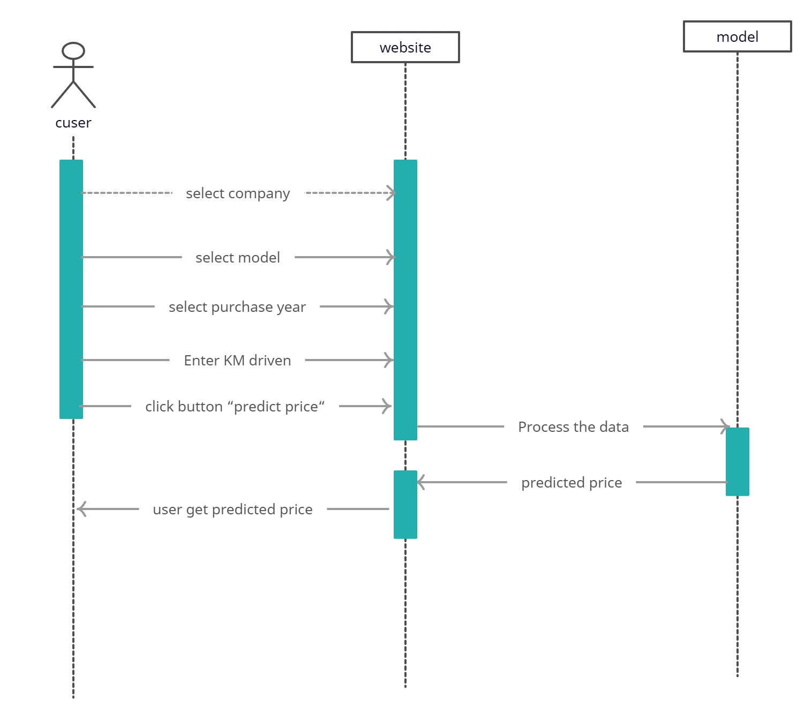

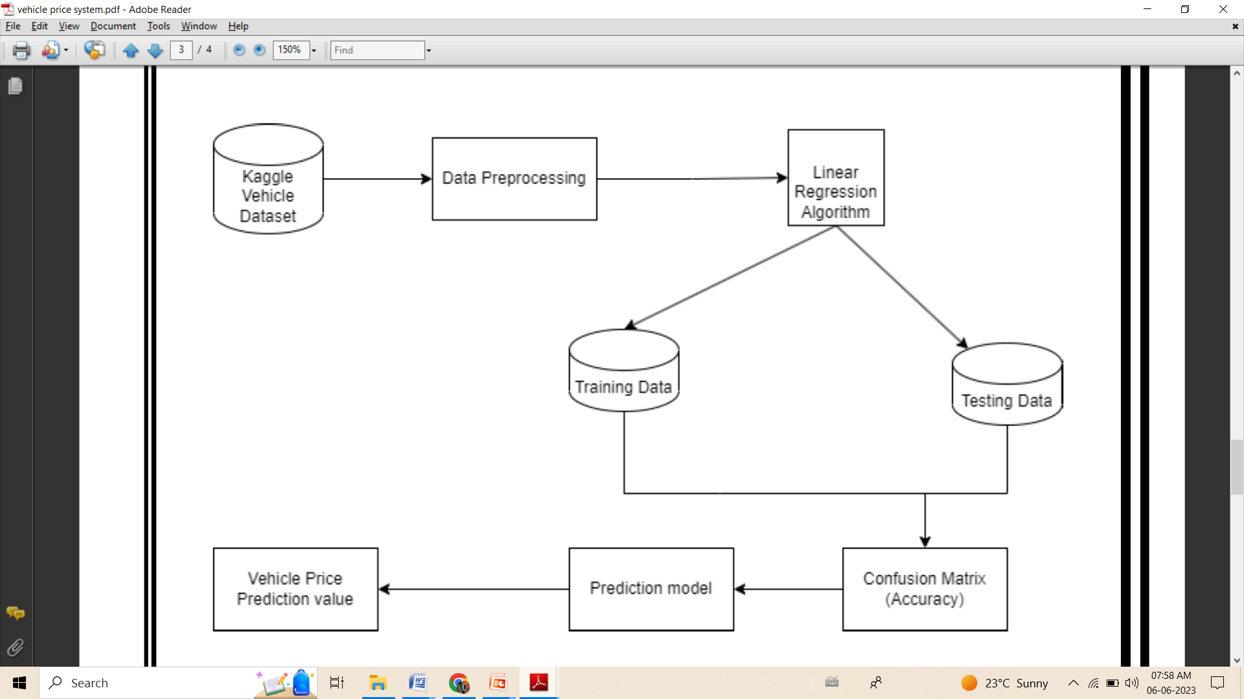**4.4 SYSTEM ARCHITECTURE**

**Chapter 5**

**Implementation**

**5.1 Software Requirements**

**1. Operating System:- windows 11**

Windows 11 is a widely used operating system that provides a robust platform for developing and running various software applications, including crop recommendation systems based on location. With its user-friendly interface, compatibility with a wide range of hardware devices, and support for programming languages and frameworks, Windows 11 offers a suitable environment for developing and deploying crop recommendation systems.

**2. Language: - Python, HTML, CSS (cascading style sheets), JavaScript**

**Python:**

Illustrate some fundamental aspects of Python, such as printing output, variable assignment, control flow, loops, functions, data manipulation, file operations, error handling, module import, and object-oriented programming. Python's versatility and extensive library ecosystem make it a popular choice for a wide range of applications, including crop recommendation systems.

**HTML:**

HTML (Hypertext Markup Language) is the standard markup language for creating and structuring web pages. It provides a set of tags or elements that define the structure and content of a web page

**CSS:**   
CSS (Cascading Style Sheets) is a stylesheet language used for describing the presentation and visual appearance of HTML (and XML) documents. It is used to define the styles, layout, and formatting of web pages, allowing developers to control the visual aspects of the content.

**5.2 Hardware requirements**

**System Type:** The website should be designed and developed to run on a 64-bit operating system, specifically the x64-based processor architecture.

**Processor:** The website should be able to run on systems with an AMD Ryzen 5 5500U with Radeon Graphics processor, which operates at a base frequency of 2.10 GHz. The website should be optimized to perform efficiently on this processor.

**RAM:** the system with 8 Giga-Bytes of RAM is needed.

**Hard Disk:** 512Giga-Bytes of memory space is needed.

**Chapter 6**

**Test Specification**

**6.1 Fundamental of testing**

**Purpose:** The primary purpose of testing is to identify defects or errors in software systems and ensure that they meet the specified requirements. Testing helps to improve the quality, reliability, and performance of the software.

**Testing Process:** Testing follows a systematic process that includes test planning, test design, test execution, and test evaluation. This process ensures that all aspects of the software are thoroughly tested and verified.

**Test Objectives:** Testing aims to achieve various objectives, including finding defects, validating the functionality of the software, verifying if it meets the requirements, ensuring usability, reliability, and performance, and assessing the overall quality of the software.

**Test Levels**: Testing is carried out at multiple levels to cover different aspects of the software. Common test levels include unit testing (testing individual components), integration testing (testing the interaction between components), system testing (testing the entire system), and acceptance testing (testing against user requirements).

**Test Techniques:** Various test techniques are employed to design effective test cases and scenarios. These include black-box testing (testing without knowledge of internal code structure), white-box testing (testing with knowledge of the internal code structure), and gray-box testing (a combination of black-box and white-box testing).

**Test Types:** Different types of tests are performed to address specific aspects of software quality. These include functional testing (testing the functionality of the software), performance testing (testing the system under specific workloads), security testing (testing for vulnerabilities and threats), usability testing (testing the user-friendliness of the software), and regression testing (retesting after modifications to ensure existing functionality is not affected).

**Test Documentation:** Documentation is an essential aspect of testing. It includes test plans, test cases, test scripts, test data, and test reports. This documentation helps in tracking the progress of testing, reproducing issues, and providing evidence of testing performed.

**Test Automation:** Test automation involves using specialized tools and scripts to automate repetitive and time-consuming testing tasks. Automation can improve efficiency, reduce human error, and enable frequent testing in agile development environments.

**Test Environment:** A suitable test environment, including hardware, software, and network configurations, is essential for accurate and reliable testing. The test environment should mimic the production environment as closely as possible.

Effective testing plays a vital role in ensuring the reliability and quality of software systems. By following the fundamentals of testing, organizations can mitigate risks, improve customer satisfaction, and deliver robust and reliable software solutions.

**6.2 Test plan**

**Test Objective:** The objective of testing the vehicle price prediction system is to ensure that it accurately estimates price of vehicle based on user input data.

**Test Environment**: Specify the environment in which the testing will be conducted, including the hardware, software, and data requirements.

Devices: Desktop computer.

Browsers: Chrome, Firefox.

Operating Systems: Windows.

**6.3 Test Cases**

**1. Test Case: Vehicle Information Input**

Description: Validate that users can accurately input vehicle details.

Test Steps:

* Navigate to the "Add Vehicle" section in the system.
* Enter valid vehicle information, including make, model, year, mileage, condition, and additional features.
* Click on the "Submit" button.
* Verify that the vehicle details are saved successfully.

**2. Test Case: Data Validation**

Description: Ensure that the system validates and handles incorrect or missing information.

Test Steps:

* Input invalid or missing vehicle details (e.g., negative mileage, invalid year).
* Attempt to submit the form.
* Verify that the system displays appropriate error messages for each invalid or missing field.

**3. Test Case: Price Prediction**

Description: Verify that the system accurately predicts the price range or estimated value of a given vehicle.

Test Steps:

* Enter valid vehicle information for a specific make, model, year, mileage, and condition.
* Click on the "Predict Price" button.
* Compare the predicted price with industry estimates or market research to ensure accuracy.

**Chapter 7**

**Conclusion and Future Scope**

**7.1 Conclusion**

In conclusion, the Used Vehicle Price Prediction System is an innovative solution designed to assist users in making informed decisions when buying or selling used vehicles. The system leverages historical sales data, market trends, and advanced machine learning algorithms to generate accurate price predictions. By analyzing various factors such as car model, company, kilometers driven, etc. the system provides users with reliable estimates of a vehicle's fair market value.

**7.2 Future Scope**

In future this machine learning model may bind with various website which can provide real time data for price prediction. Also we may add large historical data of car price which can help to improve accuracy of the machine learning model. We can build an android app as user interface for interacting with user.

**References**

1. Gongqi, S., Yansong, W., & Qiang, Z. (2011, January). New Model for Residual Value Prediction of the Used vehicle Based on BP Neural Network and Nonlinear Curve Fit. In Measuring Technology and Mechatronics Automation (ICMTMA), 2011 Third International Conference on (Vol. 2, pp. 682-685). IEEE.

2. K. Samruddhi and R. Ashok Kumar, "Used vehicle Price Prediction using K-Nearest Neighbor Based Model", International Journal of Innovative Research in Applied Sciences and Engineering, vol. 4, no. 3, pp. 686-689, 2020.

3. USED CAR PRICE PREDICTION Praful Rane1, Deep Pandya2, Dhawal Kotak, Information Technology Engineering, Padmabhushan Vasantdada Patil Pratisthan College of Engineering, Maharashtra India.